NEW BRIGHTON SCHOOL OF THE PHILIPPINES, INC

Quezon Ave., Brgy. Dadiangas West, General Santos City

Email Address: [newbrightonschoolphinc@gmail.com](mailto:newbrightonschoolphinc@gmail.com)

Contact Numbers: (083) 877- 4985 and 0917- 8426097

____________________________________________________________________________________

**Dart**

Venue: Room B203

Eligibility:

1. Must be Bonafide students of NBSPI in the S. Y. 2023 - 2024

Mechanics:

1. Each division must have two (2) participants. (1 men & 1 women)
2. The game darts is to toss small pointed missiles or darts at a circular target or dartboard that is affixed to a wall
3. To decide who starts, each player throws one dart at the bullseye - the one closest begins the game.
4. Each player throws three darts per turn and scores are tallied based on where the dart lands.
5. Hitting the bullseye, which is located in the center circle, awards high points.
6. Any dart that misses, bounces off or falls from the board earns no score. If a dart sticks in another dart, it counts as a throw and gets no score.
7. The game demands strategy and accuracy.

Scoring Rules of Dart:

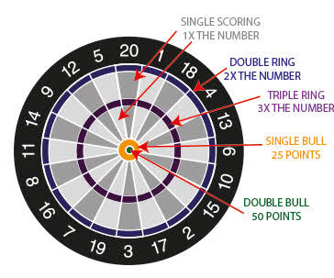

MATERIALS NEEDED:

1. DART BOARD
2. DARTS
3. FLOOR MARKER
4. SCORING SHEET